

***Manav Rachna University***

***Department of Computer Science & Technology***

Object Oriented Programming

***PROJECT***

***(Using Java)***

NAME:ROLL NO. :

**Mukul Singh 2K17CSUN01132**

**Niharika Yadav 2K17CSUN01133**

**Nischal Kumar 2K17CSUN01134**

BRANCH**: B.TECH(C.S.E.)** Submitted to:

SECTION**: 3-C Mrs. Mamta Arora**

**Mrs. Riya Sapra**

**SYNOPSIS**

The system **Training and placement cell system**

can be used to manage all the data of various type of jobs available and companies recruiting. It will support both stand alone and also networking environment. The system uses Java. The main modules involved in this system are:

* Admin updating data
* User looking for jobs
* Database of users and jobs
* Recruiter searching for users.

Product Information:

Product Perspective:

This project is mainly intended for automating this procedure that can help the people who belong to the T&P cell by saving their time ,based on this basic operation actually their activity is under two steps the first one is we have to maintain the list of students and their credit records and the second job is to maintain the company details and based on the company requirements we need to select the students and we need to make the list of students, and here informing is through notice boards , where as this is also a bit old fashioned task, which can be automated in our proposed system by sending mails to the respective candidates. This proposed system is far advantageous than the existing one in many cases such as retrieving the student details is easily maintained in a manner that with just one click we can easily attain the details of the company such as the responsible person contacts and company contact details such as address and phone numbers can be maintained.

T&P cell mainly include the details of students, based on these requirements specified by various companies, appropriate students list must be generated. The percentage of the students must be appropriate and true. We should be able to generate a notice so that we notify all the departments the corresponding information about campus recruitment drives. We need top view the student details.

Mini Project:

Training and Placement Cell System

**Features of System:**

* The registered user can directly view the jobs, which are posted by admin.

* If the user is interested, he can directly send the request.

* If the recruiter wants to see the user resume he can just directly search the user and he can find the username.

* **Source Codes**
  + **Portal.java (main)**

**package** proj;

**import** java.util.*;

**public** **class** Portal {

**public** **static** **void** main(String[] args) {

// **TODO** Auto-generated method stub

System.***out***.println("Welcome");

**new** Inter();

}

}

* + **Inter.java**

**package** proj;

**import** java.util.Scanner;

**public** **class** Inter {

Inter(){

Scanner sc= **new** Scanner(System.***in***);

System.***out***.println("\nWho are you:");

System.***out***.println("\nAdmin- a\tUser- u \t Recruiter- r");

String q=sc.nextLine();

**if**(q.compareTo("a")==0) {

**new** InterA();

}

**if**(q.compareTo("u")==0) {

**new** InterU();

}

**if**(q.compareTo("r")==0) {

**new** InterR();

}

**else** {

System.***out***.println("Wrong entry!");

**new** Inter();

}

}

}

* + **Log_a,java**

**package** proj;

**public** **class** Log_a {

**int** i,b1,an = 4;

String a[]= {"Abc","Bcd","Cde","Def","Efg"};

String ap[]= {"Ab","Bc","Cd","De","Ef"};

**int** match(String b,String bp)

{ **for**(i=0;i<=an;i++) {

**if**(b.compareTo(a[i])==0 && bp.compareTo(ap[i])==0)

{

b1=1;

**break**;

}

**else**

{

b1=0;

}

}

**if**(b1==1)

{

**return** 1;

}

**else** {

**return** 0;

}

}

}

* + **Log_u.java**

**package** proj;

**import** java.util.*;

**public** **class** Log_u {

**static** Scanner *sc*= **new** Scanner(System.***in***);

**static** **int** *i*,*b1*,*an* = 4;

**static** String *u*[]= {"U1","U2","U3","U4","U5"};

**static** String *up*[]= {"Ab","Bc","Cd","De","Ef"};

**static** String *uname*[]= {"Deepak","Mukul","Rishab","Niharika","Nischal"};

**static** String *ugrad*[]= {"B.tech,M.tech,Bsc","B.tech","B.tech","Management","B.tech"};

**int** match(String b,String bp)

{ **for**(*i*=0;*i*<=*an*;*i*++) {

**if**(b.compareTo(*u*[*i*])==0 && bp.compareTo(*up*[*i*])==0)

{

*b1*=1;

**break**;

}

**else**

{

*b1*=0;

}

}

**if**(*b1*==1)

{

**return** 1;

}

**else** {

**return** 0;

}

}

**static** **void** search()

{ **int** l=0;

System.***out***.println("\nEnter User_id:");

String u1=*sc*.nextLine();

**for**(*i*=0;*i*<=*an*;*i*++)

{

**if**(u1.compareTo(*u*[*i*])==0)

{

l=*i*;

**break**;

}

**else** {

l=6;

}

}

**if**(l==6)

{

System.***out***.println("\nCan't find the user.");

}

**else** {

System.***out***.println("\nU_id |\t U_name |\t Gradaduation");

System.***out***.println(*u*[l]+"\t "+*uname*[l] +"\t "+*ugrad*[l] );

}

}

* + **Log_r.java**

**package** proj;

**public** **class** Log_r {

**int** i,b1,an = 4;

String r[]= {"R1","R2","R3","R4","R5"};

String rp[]= {"Ab","Bc","Cd","De","Ef"};

**int** match(String b,String bp)

{ **for**(i=0;i<=an;i++) {

**if**(b.compareTo(r[i])==0 && bp.compareTo(rp[i])==0)

{

b1=1;

**break**;

}

**else**

{

b1=0;

}

}

**if**(b1==1)

{

**return** 1;

}

**else** {

**return** 0;

}

}

}

* + **InterA.java**

**package** proj;

**import** java.util.Scanner;

**public** **class** InterA {

Scanner sc=**new** Scanner(System.***in***);

InterA(){

String a,ap;

Log_a l1= **new** Log_a();

System.***out***.println("\nEnter Admin id and password:");

a=sc.nextLine();

ap=sc.nextLine();

**int** c= l1.match(a, ap);

**if**(c==1)

{

System.***out***.println("\nWelcome admin.");

Amenu();

}

**if**(c==0)

{

System.***out***.println("\nWrong username or password");

**new** Inter();

}

}

**void** Amenu() {

System.***out***.println("\nMENU:");

System.***out***.println("\nEnter What would you like to do");

System.***out***.println("\na= Add Job,\tb=Details of jobs\tc=Get details of applicants\tx= Exit\ty=back to main menu");

String t= sc.nextLine();

**if**(t.compareTo("a")==0) {

Jobs.*addJob*();

Amenu();

}

**if**(t.compareTo("b")==0) {

Jobs.*getDetails*();

Amenu();

}

**if**(t.compareTo("c")==0) {

Jobs.*display*();

Amenu();

}

**if**(t.compareTo("x")==0) {

System.***out***.println("\nExit");

System.*exit*(0);

}

**if**(t.compareTo("y")==0) {

System.***out***.println("\nBack to main menu:");

**new** Inter();

}

**else** {

System.***out***.println("\nWrong entry!");

Amenu();

}

}

}

* + **InterU.java**

**package** proj;

**import** java.util.Scanner;

**public** **class** InterU {

Scanner sc=**new** Scanner(System.***in***);

InterU(){

String a,ap;

Log_u l1= **new** Log_u();

System.***out***.println("\nEnter User id and password:");

a=sc.nextLine();

ap=sc.nextLine();

**int** c= l1.match(a, ap);

**if**(c==1)

{

System.***out***.println("\nWelcome User.");

Umenu();

}

**if**(c==0)

{

System.***out***.println("\nWrong username or password");

**new** Inter();

}

}

**void** Umenu() {

System.***out***.println("\nMENU:");

System.***out***.println("\nEnter What would you like to do");

System.***out***.println("\na=Details of jobs\tb=Apply for job \t x= Exit \t y=back to main menu");

String t= sc.nextLine();

**if**(t.compareTo("b")==0) {

Jobs.*apply*();

Umenu();

}

**if**(t.compareTo("a")==0) {

Jobs.*getDetails*();

Umenu();

}

**if**(t.compareTo("x")==0) {

System.***out***.println("\nExit");

System.*exit*(0);

}

**if**(t.compareTo("y")==0) {

System.***out***.println("\nBack to main menu:");

**new** Inter();

}

**else** {

System.***out***.println("\nWrong entry!");

Umenu();

}}}

* + **InterR.java**

**package** proj;

**import** java.util.Scanner;

**public** **class** InterR {

Scanner sc=**new** Scanner(System.***in***);

InterR(){

String a,ap;

Log_r l1= **new** Log_r();

System.***out***.println("\nEnter Recruiter id and password:");

a=sc.nextLine();

ap=sc.nextLine();

**int** c= l1.match(a, ap);

**if**(c==1)

{

System.***out***.println("\nWelcome Recruiter.");

Rmenu();

}

**if**(c==0)

{

System.***out***.println("\nWrong username or password");

**new** Inter();

}

}

**void** Rmenu() {

System.***out***.println("\nMENU:");

System.***out***.println("\nEnter What would you like to do");

System.***out***.println("\na=Details of jobs\tb=Get details of applicants \t s=search \t x= Exit\t y=Back to main menu");

String t= sc.nextLine();

**if**(t.compareTo("s")==0) {

Log_u.*search*();

Rmenu();

}

**if**(t.compareTo("a")==0) {

Jobs.*getDetails*();

Rmenu();

}

**if**(t.compareTo("b")==0) {

Jobs.*display*();

Rmenu();

}

**if**(t.compareTo("x")==0) {

System.***out***.println("\nExit");

System.*exit*(0);

}

**if**(t.compareTo("y")==0) {

System.***out***.println("\nBack to main menu:");

**new** Inter();

}

**else** {

System.***out***.println("\nWrong entry!");

Rmenu();

}

}

}

* + **Jobs.java**

**package** proj;

**import** java.util.Scanner;

**public** **class** Jobs {

**static** Scanner *sc*= **new** Scanner(System.***in***);

**public** **static** String *jid*[]= **new** String[100];

**public** **static** **int** *jidl*=0;

**public** **static** String *jname*[]= **new** String[100];

**public** **static** **int** *jnl*=0;

**public** **static** String *jdetail*[]= **new** String[100];

**public** **static** **int** *jdl*=0;

**public** **static** String *j_user*[]= **new** String[100];

**public** **static** **int** *j_ul*=0;

**public** **static** String *j_id*[]= **new** String[100];

**public** **static** **int** *j_il*=0;

**static** **void** addJob()

{

System.***out***.println("\nEnter job details:");

System.***out***.println("Enter job id:");

*jid*[*jidl*]= *sc*.nextLine();

*jidl*++;

System.***out***.println("Enter Company name:");

*jname*[*jnl*]= *sc*.nextLine();

*jnl*++;

System.***out***.println("Enter details of job:");

*jdetail*[*jdl*]= *sc*.nextLine();

*jdl*++;

}

**static** **void** getDetails()

{

**int** i;

System.***out***.println("\nJob_id\t| Job_name\t| Job_details |");

**if**(*jidl*==0)

{

System.***out***.println("No job available 'yet'.");

**return**;

}

**for**(i=0;i<*jidl*;i++)

{

System.***out***.println(*jid*[i]+"\t"+*jname*[i]+"\t"+*jdetail*[i]);

}

}

**static** **void** apply()

{

System.***out***.println("\nEnter details to aplly for job");

System.***out***.println("\nEnter username:");

*j_user*[*j_ul*]=*sc*.nextLine();

*j_ul*++;

System.***out***.println("\nEnter Job id:");

*j_id*[*j_il*]=*sc*.nextLine();

*j_il*++;

}

**static** **void** display()

{**int** i;

System.***out***.println("\nDetails of applicants.");

System.***out***.println("\nUser_id\tJob_details");

**for**(i=0;i<*j_il*;i++)

{

System.***out***.println(*j_user*[i]+"\t"+*j_id*[i]);

}

}

}

* **Execution**

**Main menu:**

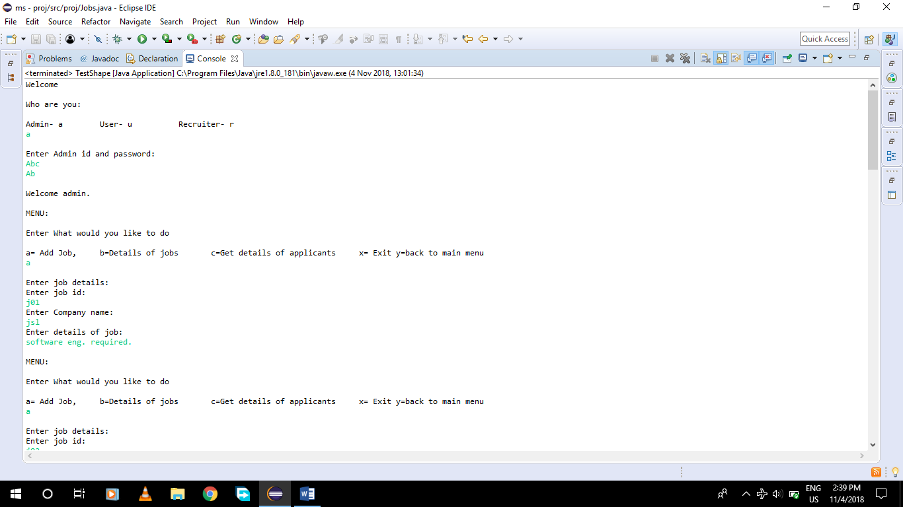

**Admin login:**



**Admin menu:**



**Add job(admin):**

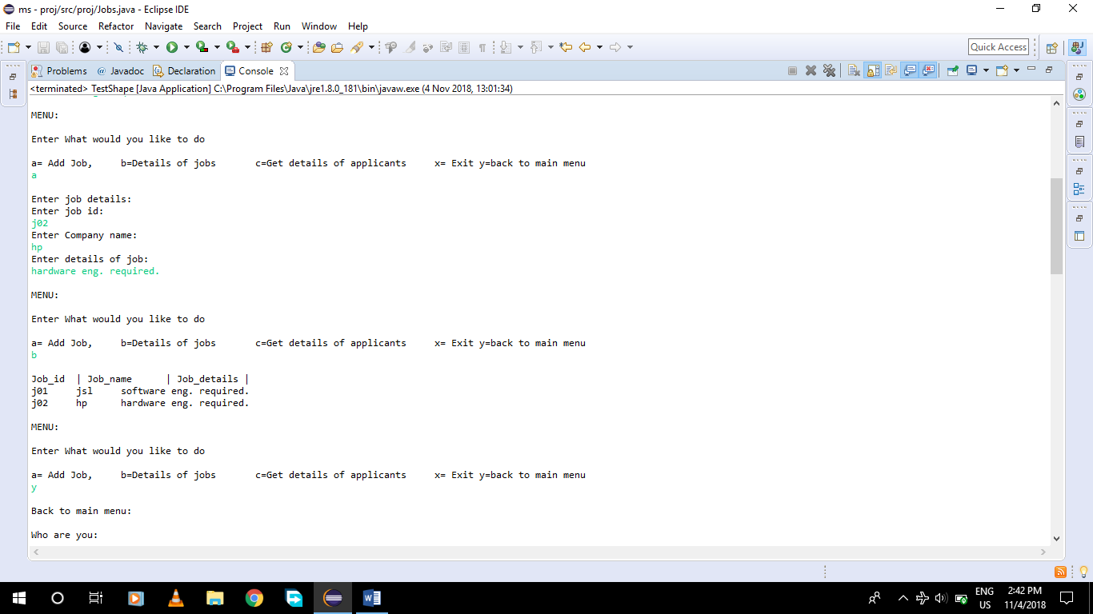

**Detail of jobs:**



**User login:**

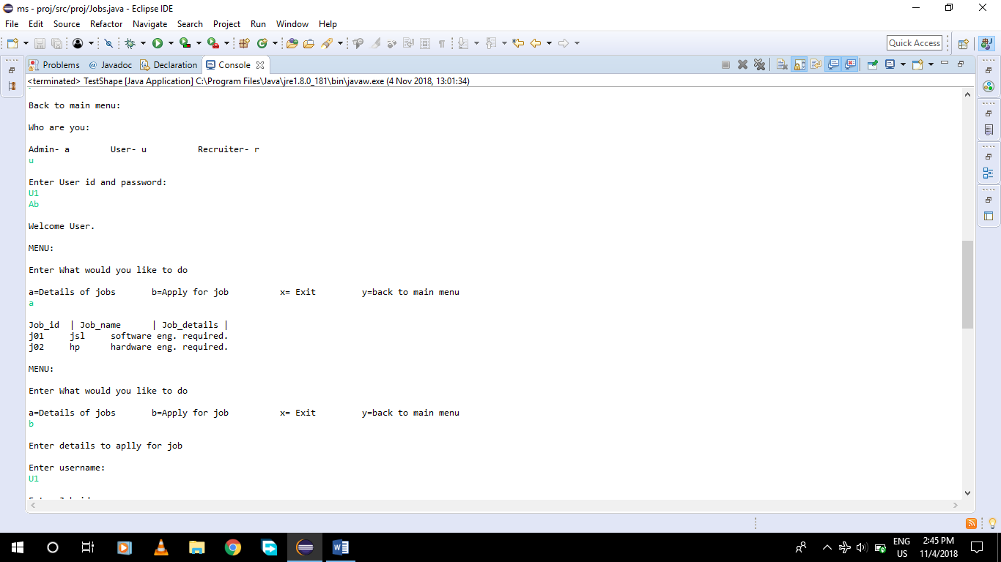

**User Menu and Detail of jobs:**



**Apply for Job(user):**

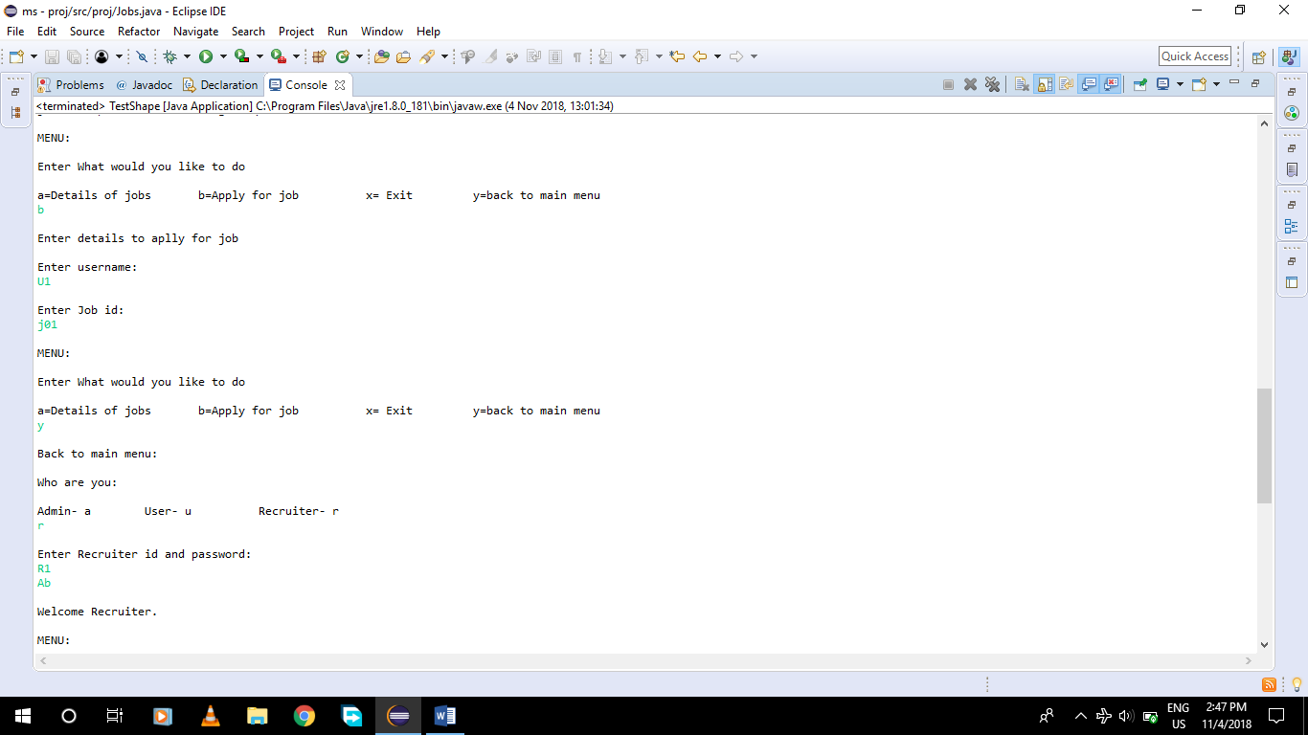

**Recruiter login:**



**Recruiter menu:**

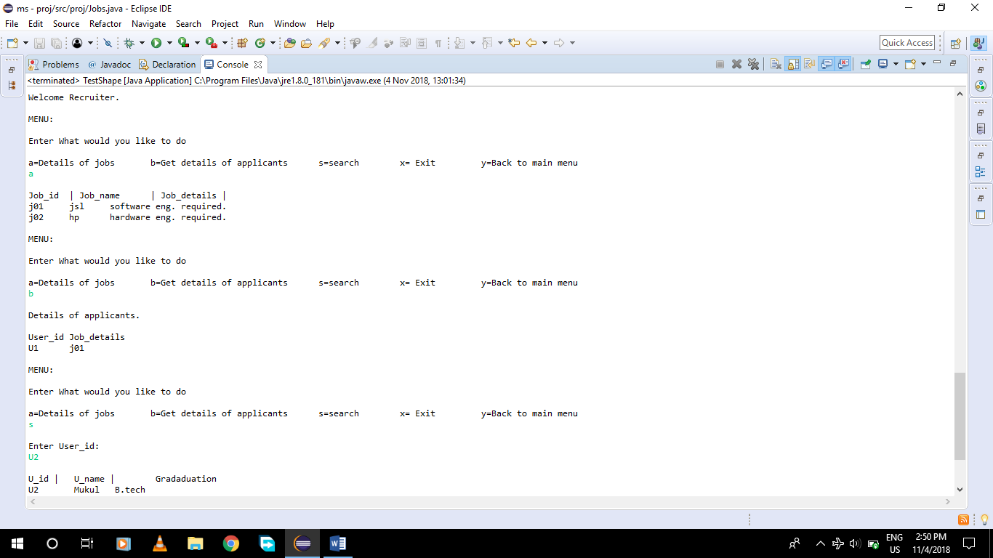

**Recruiter getting detail of applicants:**



**Recruiter search for any User’s details:**

